The Science of Computing III Living with Cyber

Workbook: More on Objects-ANSWERS Pillar: Computer Programming

1. Fill out the following table.
 | Definition | Purpose and/or how it is dealt with
Abstraction | The ability to ignore the details of parts of a system in order to focus our attention at a higher level. | Useful for only focusing on the details of a program we are currently interested in
Modularization | Act of dividing a whole into well-defined parts that can be built and examined separately. | Allows you to split a complicated task into sub tasks so as to better organize and arrange your code. Each module can be focused on a single, small aspects of your program
Method lookup | Solves the problem of finding the right method to call in a class hierarchy. The idea of having multiple methods with the same name in multiple classes is called polymorphism. | Used internally by Python to handle polymorphism.
Single inheritance | When a class inherits traits from a single superclass. Some languages support single inheritance only. | Used to create an inheritance chain so as to better organize your code.
Multiple inheritance | When a class inherits traits from two or more superclasses. Some languages, like Python, support multiple inheritance. | If a class need state and behavior from two or more classes, this is useful.
Abstract method | A way of promising that any subclasses of some superclass will provide implementation details for that method | Used for when we don’t have all the information we need to implement a given method in a class, yet we want sub classes that will have that information to implement the method.
Abstract class | Classes designed solely to be used as superclasses and never to be instantiated. | Certain classes should only act as a superclass and it really doesn’t make sense to instantiate them. Marking a class as abstract prevents it from being instantiated.
Concrete class | Classes that do not have any abstract methods. That is, all its methods are concrete methods. | This is the basic, standard approach to creating a class. Any class that isn’t abstract is considered concrete.
Unit | Any reasonably self-contained component of a program. | Concept that helps us talk about parts of our code as consolidated groups. A unit can be a single function, a single class, or even an entire module of classes.
Coupling | Refers to links between the separate units of a program | We aim for loose coupling as we want classes to not rely on the exact behavior of another class. Having tight coupling means if one class changes, we might have to change several others. Loose coupling makes classes more independent.
Cohesion | Refers to the number and diversity of tasks that a single unit is responsible for | We aim for high cohesion. We want units to focus on a single goal and every thing it does should be focused on that goal. Think about a “junk drawer” or “misc drawer” in your kitchen. Very hard to find things in there. We want to avoid doing that to our code.

2. Create the code to represent the following class diagram. Note that the pass keyword is an acceptable way to stub out a function for later implementation in Python.
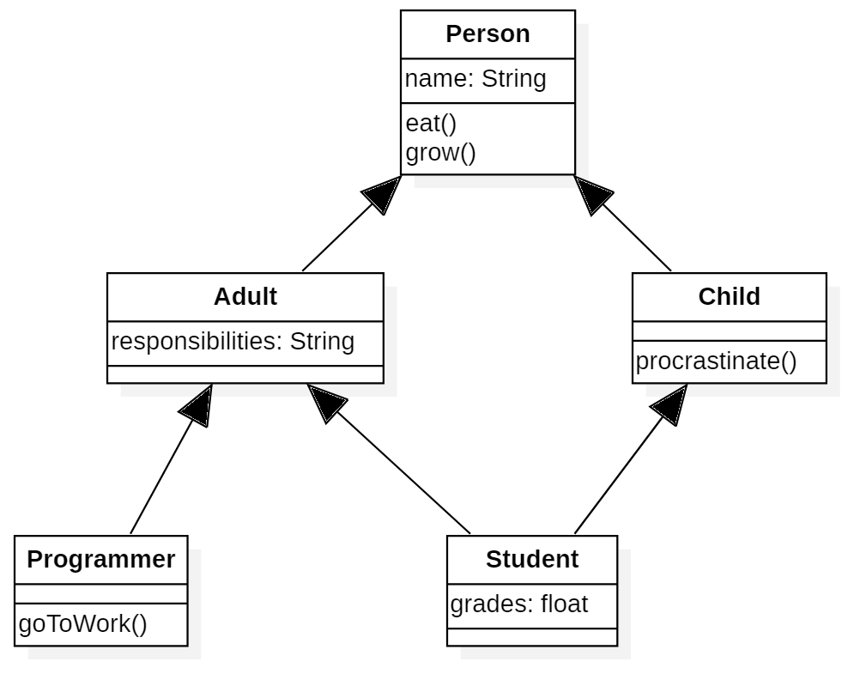
class Person(object):
def __init__(self, name):
self.name = name

def eat(self):
pass
def grow(self):
pass

class Child(Person):
def __init__(self, name):
Person.__init__(self, name)

def procrastinate(self):
pass

class Adult(Person):
def __init__(self, name, responsibilities):
Person.__init__(self, name)
self.responsibilities = responsibilities

class Programmer(Adult):
def __init__(self, name):
Adult.__init__(self, name, "programming")

def goToWork(self):
pass

class Student(Adult, Child):
def __init__(self, name):
Adult.__init__(self, name, "study")
Child.__init__(self, name)
self.grades = 0.0

3. Use the following class stubs to draw a representative class diagram that shows classes, members, and relationships. Note that the pass keyword is an acceptable way to stub out a function for later implementation in Python.

class OperatingSystem(object):
def __init__(self, version):
self.version = version

def run(self):
pass

class Linux(OperatingSystem):
def __init__(self):
pass

def openTerminal(self):
pass

class Mac(OperatingSystem):
def __init__(self):
pass
def openFinder(self):
pass

class Windows(OperatingSystem):
def __init__(self):
pass

def openExplorer(self):
pass

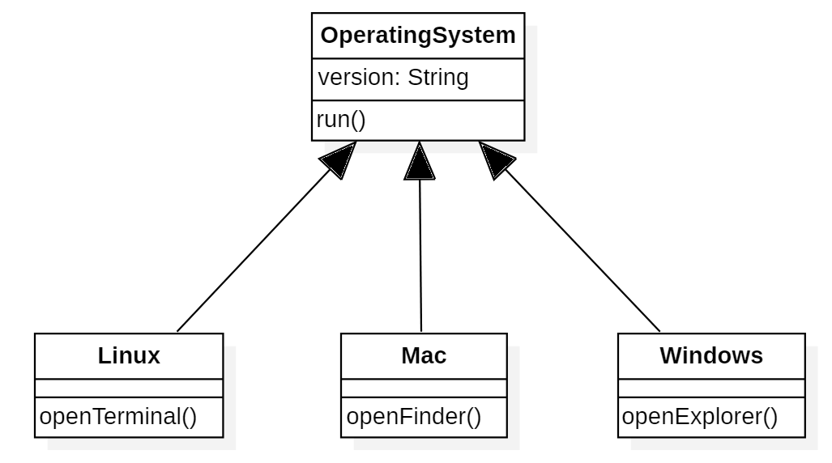

4. What is the output of the following program?

import abc

class Animal(object):
__metaclass__ = abc.ABCMeta

def __init__(self):
""" constructs a new Animal """

def __str__(self):
return "Animal"

class Mammal(Animal):
__metaclass__ = abc.ABCMeta

def __init__(self):
Animal.__init__(self)

def __str__(self):
return "mammal"

class Ape(Mammal):
def __init__(self, owner = "Cincinnati zoo"):
Mammal.__init__(self)
self.owner = owner

def __str__(self):
return "{}".format(self.owner) + ", Ape, " + Mammal.__str__(self)

class Wolf(Mammal):
def __init__(self):
Mammal.__init__(self)

def __str__(self):
return "wolf"

class Snail(Animal):
def __init__(self):
Animal.__init__(self)

a1 = Ape()
a2 = Ape("Kong")
w1 = Wolf()
s1 = Snail()
print(a1)
print(a2)
print(w1)
print(s1)

Cincinnati zoo, Ape, mammal
Kong, Ape, mammal
wolf
Animal

